Activities to be performed by Contractor.

Submission of Invoice.
- For invoice Submission contractor has to click on “New” button.
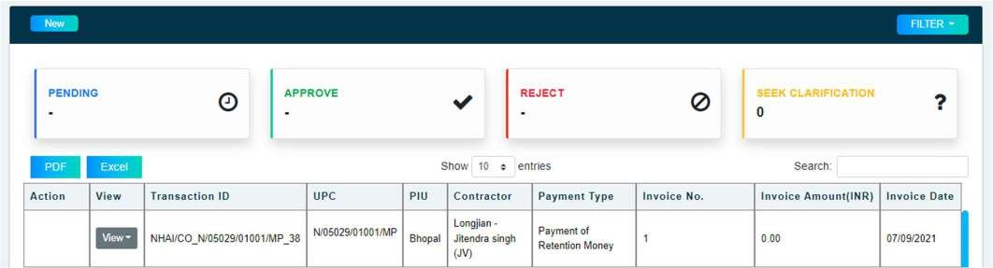

- On click of “New” button, form will open Contractor to fill form with required information and upload all mandatory documents.
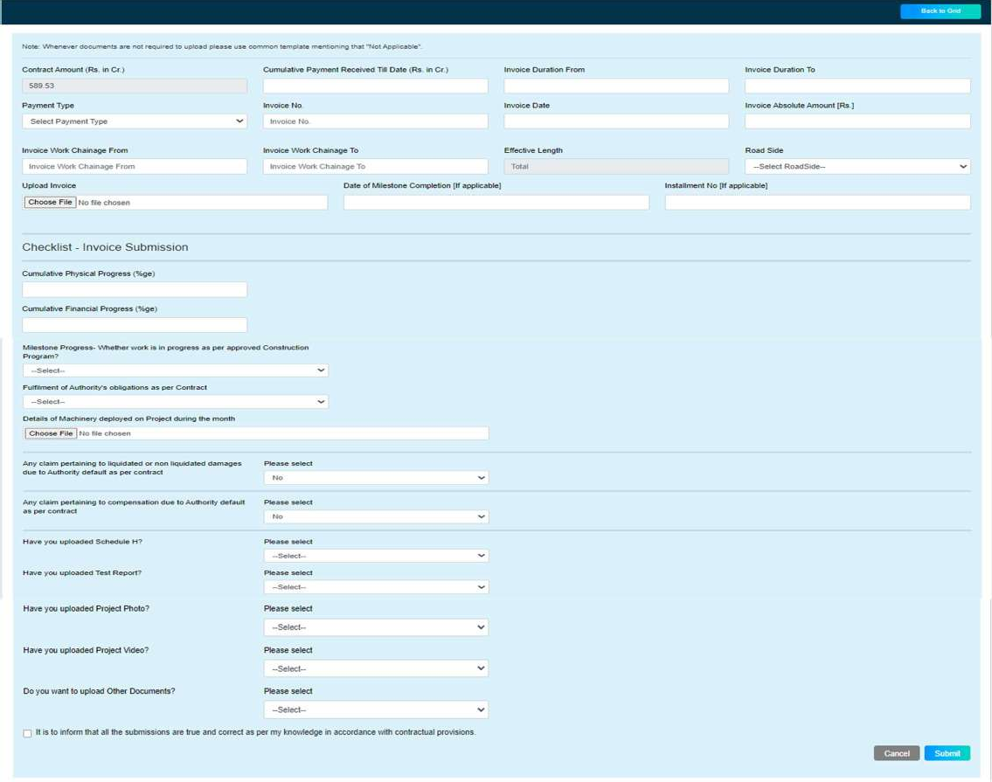

- After click on submit button, Dairy function will open where contractor has to add note using digital signature and upload any other reference document
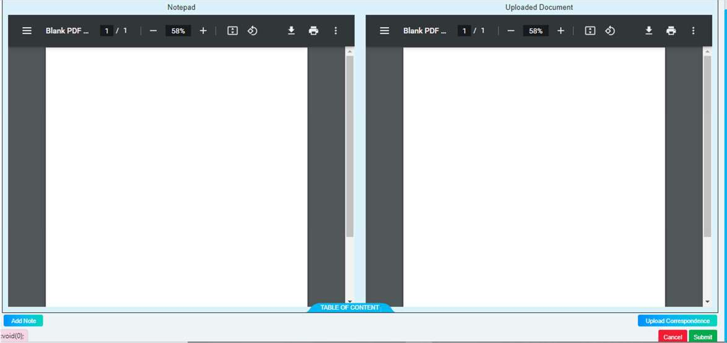

View Submission & Activity Log
- After Submission of invoice, the invoice gets populated in grid and Contractor can view submission & Activity log by clicking on “View” button.
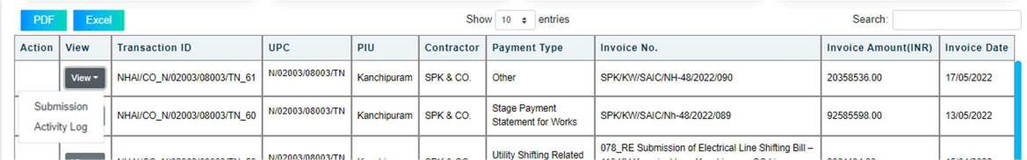

Submit clarification
- When ADMIN seeks clarification from Contractor on the submitted invoice, “Submit clarification” option appears in Contractor login.
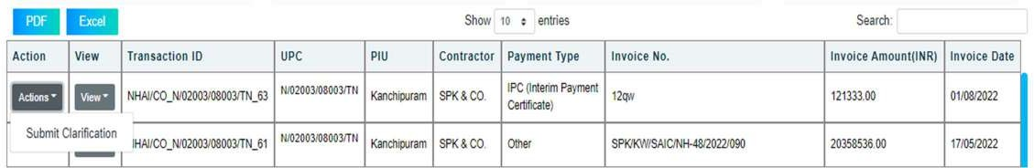

- On clicking “Submit Clarification” dairy function will open and contractor can submit clarification by add note using digital signature and upload document(optional).
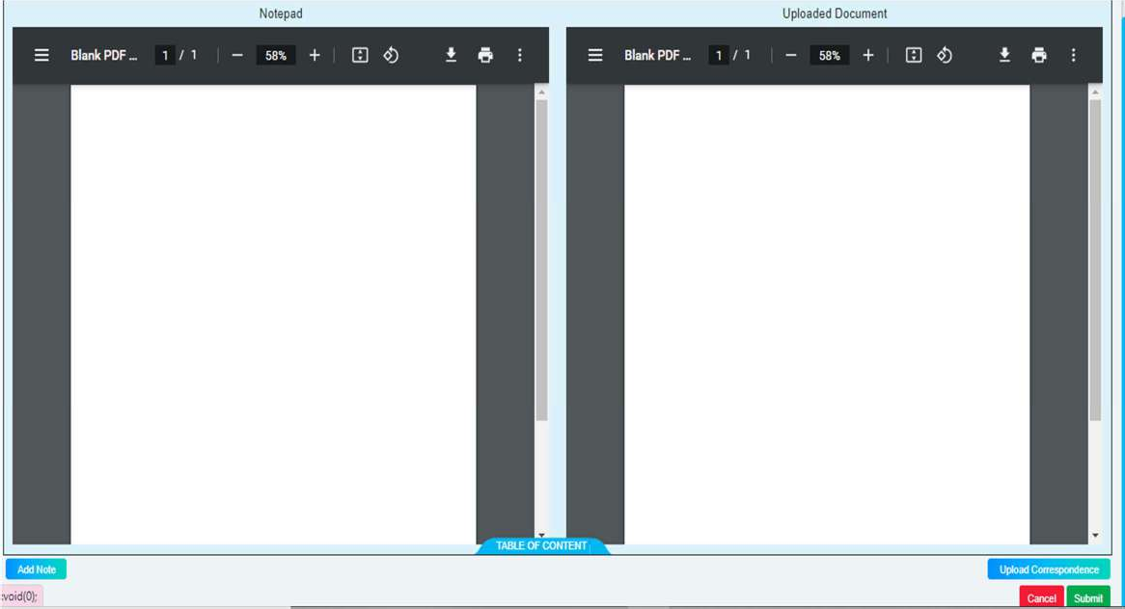

Withdraw Invoice
- Contractor can withdraw invoice until ADMIN has not performed any action on the submitted claim.
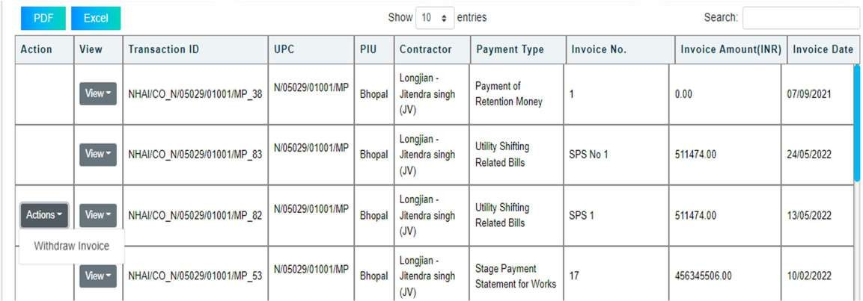

- On clicking “Withdraw Invoice” dairy function will open and contractor can withdraw invoice by add note using digital signature and upload document(optional).
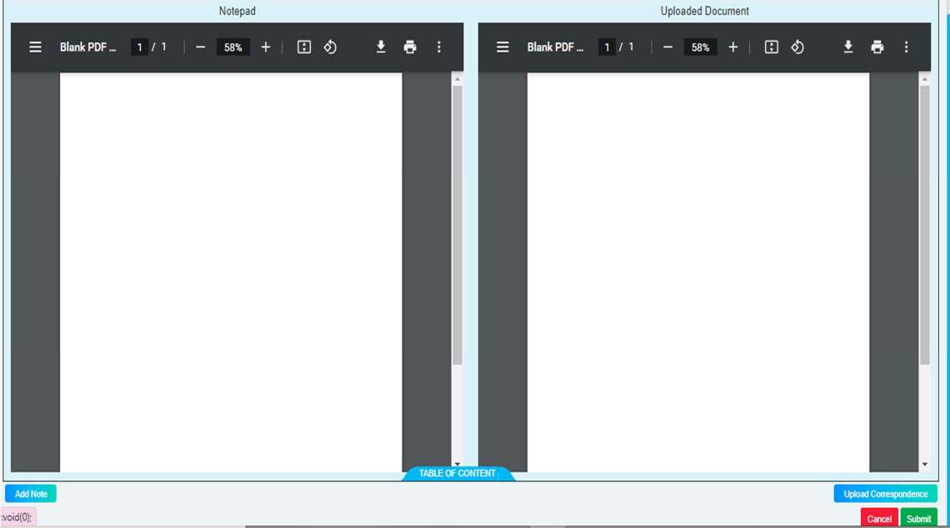

Activities to be performed by ADMIN

ADMIN invoice submission.

Submission of Invoice
      - For invoice Submission ADMIN has to click on “New” button.
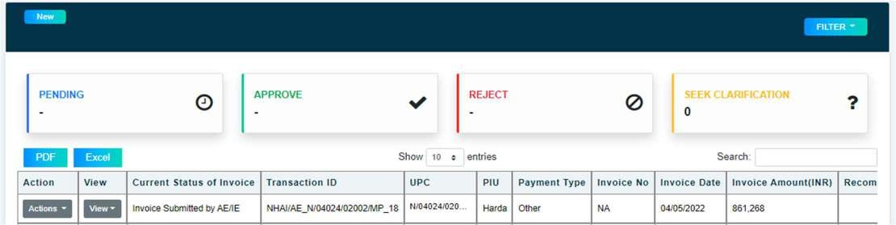

      - On click of “New” button, form will open ADMIN to fill form with required information and upload all mandatory documents.
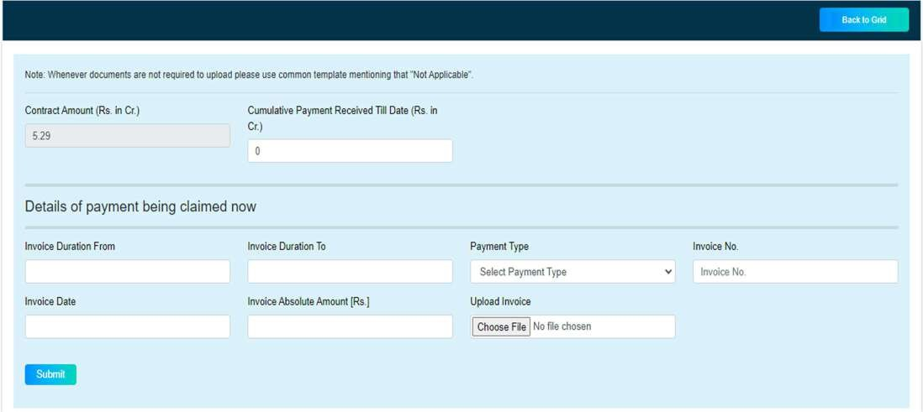

      - After click on submit button, Dairy function will open where ADMIN has to add note using digital signature and upload any other reference document (For Digital Signature Refer Annexure 1).
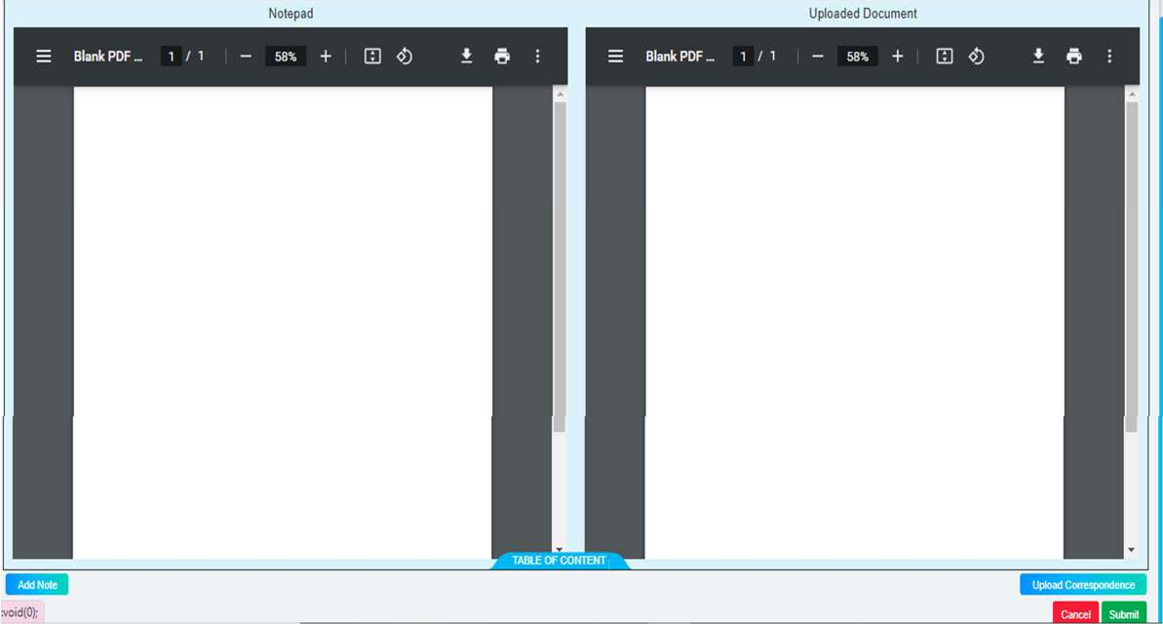

View Submission & Activity Log
      - After Submission of invoice, the invoice gets populated in grid and ADMIN can view submission & Activity log by clicking on “View” button.
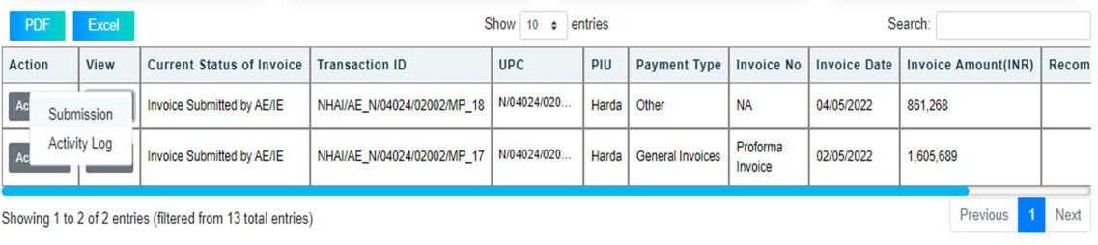

Submit clarification
      - When CLIENT/GOVERNMENT seeks clarification from ADMIN on the submitted invoice, “Submit clarification” option appear in ADMIN login.
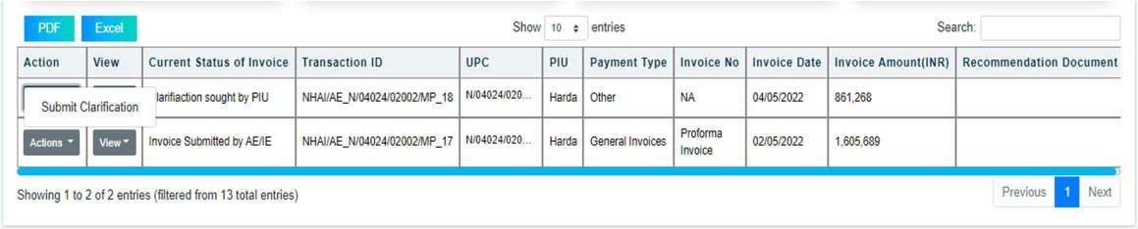

      - On clicking “Submit Clarification” dairy function will open and ADMIN can submit clarification by add note using digital signature and upload document(optional).
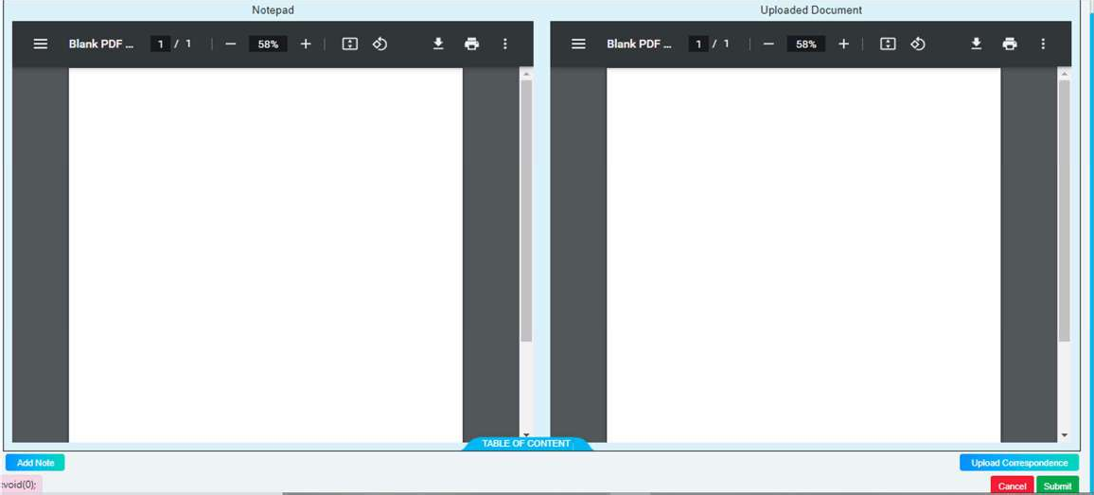

Withdraw Invoice
      - ADMIN can withdraw invoice until CLIENT/GOVERNMENT has not performed any action on the submitted claim.
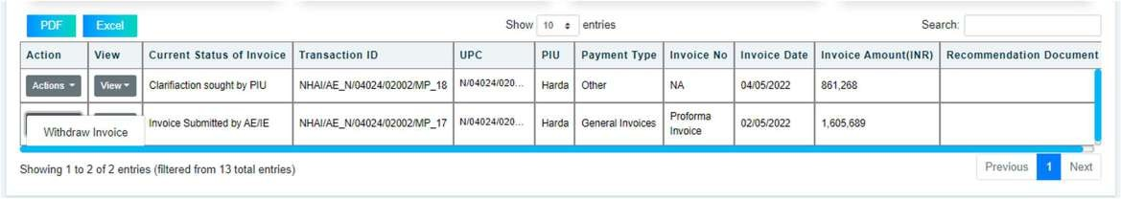

      - On clicking “Withdraw Invoice” dairy function will open and DPR Consultant has to add note using digital signature and upload document(optional).
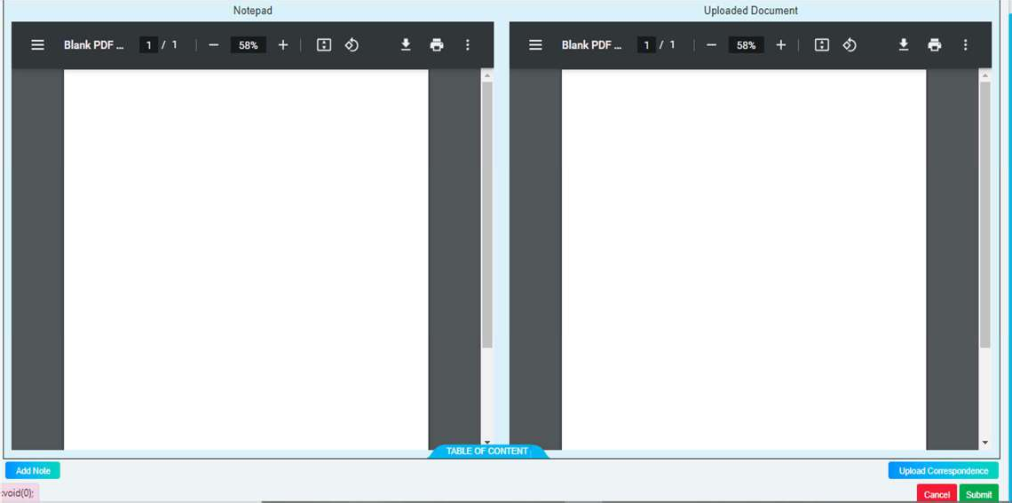

Contractor invoice processing.

View submitted invoice by Contractor.
      - After submission of invoice by contractor the details get displayed in ADMIN grid.
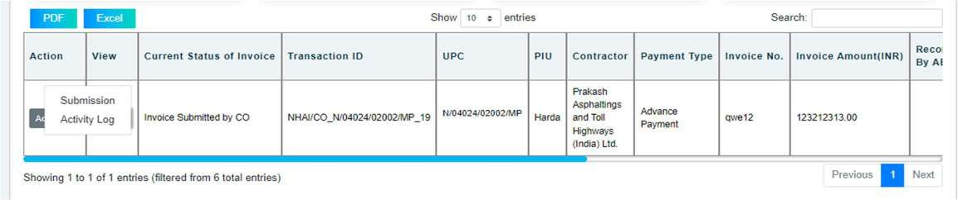
      - ADMIN can view submissions & activity log by clicking on “View” button.

Processing for submitted invoice by Contractor.
      - ADMIN to process Contractor invoice by clicking on “Recommend”.
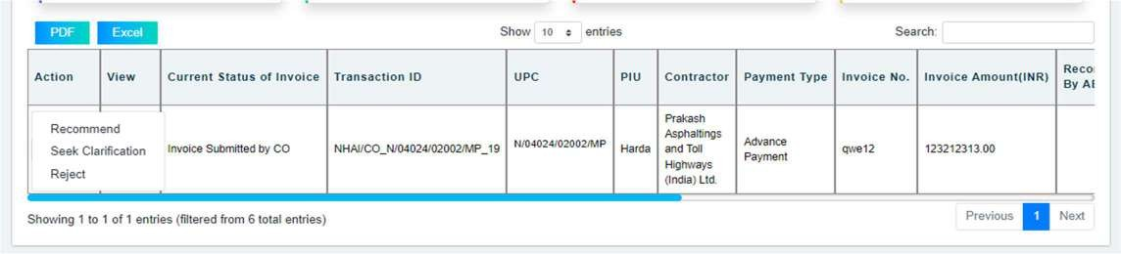

Note- If ADMIN can processes the contractor invoice by selecting ‘Provisional Payment’ or ‘Final Payment,
        - If ADMIN select Provisional payment transaction Id gets split in two parts (i.e.) Provisional payment & Balance payment.
For provisional payment, Transaction ID gets appended with “_P”. For balance payment, Transaction ID gets appended with “_B”.
        - If ADMIN processes contractor invoice by selecting “Full Payment” then Transaction ID gets append with “_F”. and will be processed as a single invoice.

      - On clicking “Recommend” pop up will open, ADMIN has to fill all details in pop up and submit.
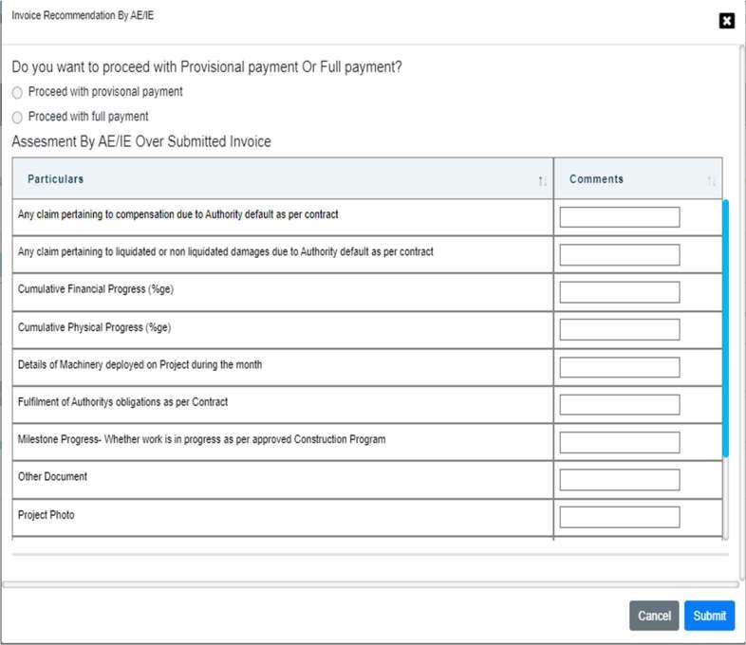

      - On submission of pop up, digital calculation will open, ADMIN to fill calculation sheet and submit using digital signature.
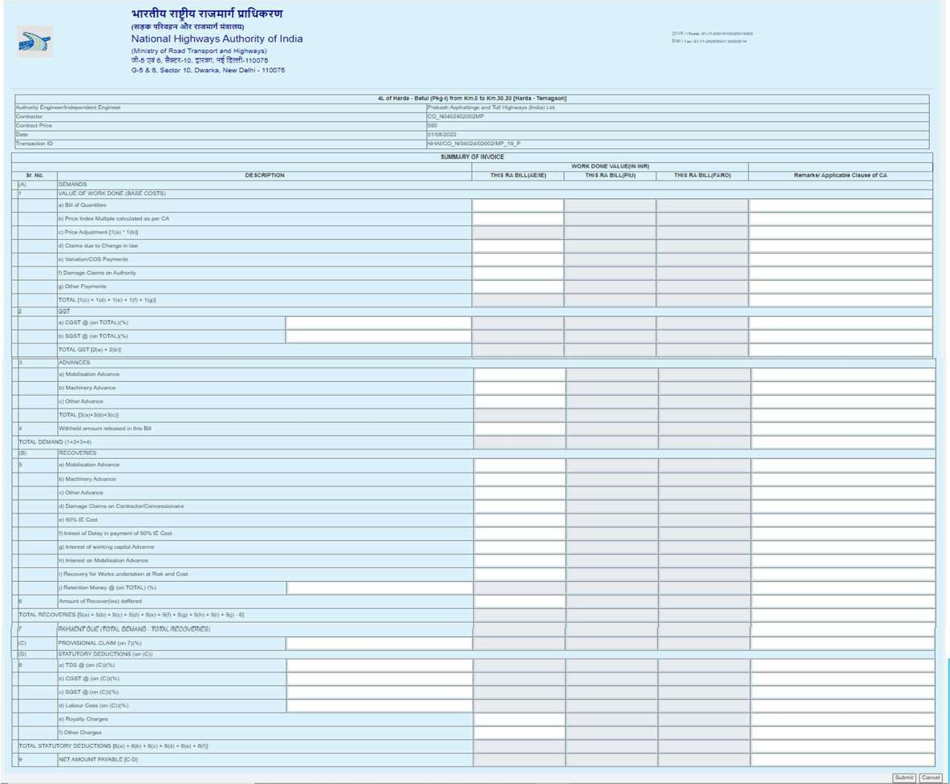

      - ADMIN can recommend 75% to 90% of the Net Payable amount, If he has proceeded with “Provisional Payment”.
      - ADMIN can recommend balance amount by proceeding with “Balance Payment”.
      - ADMIN can recommend up to 100% if he has proceeded with “Full Payment”.

      - On submission of calculation sheet, dairy function will open and ADMIN has to submit by add note using digital signature and upload document(optional).
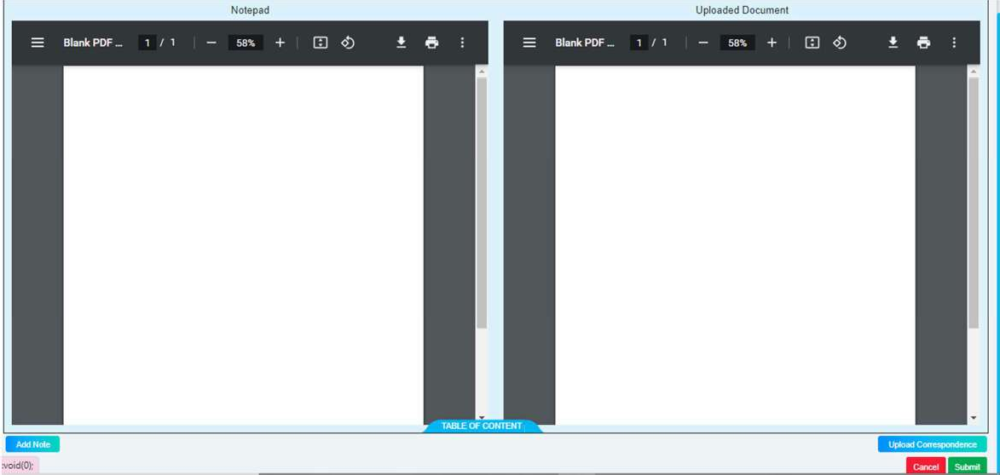

Seek Clarification from Contractor.

      - ADMIN can seek clarification from Contractor by clicking on “Seek Clarification”.
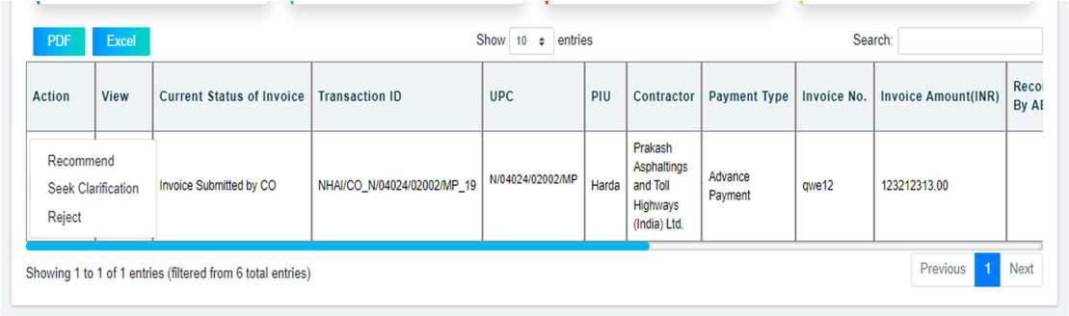

      - On clicking “Seek Clarification” dairy function will open and ADMIN can seek clarification by add note using digital signature and upload document(optional).
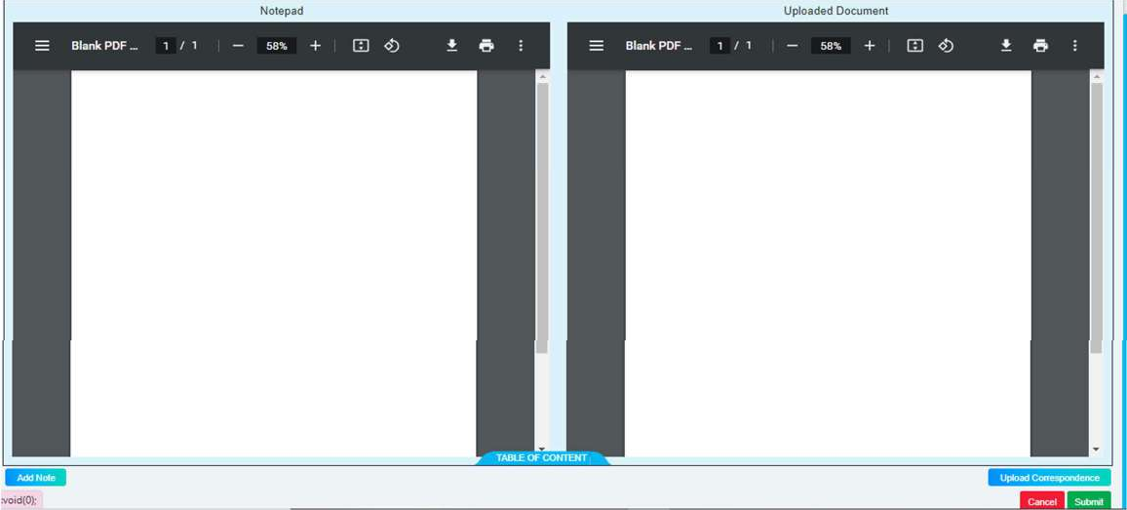

Submit clarification to CLIENT/GOVERNMENT.
      - When CLIENT/GOVERNMENT seeks clarification from ADMIN over recommended Contractor invoice, “Submit clarification” option appear in ADMIN login.
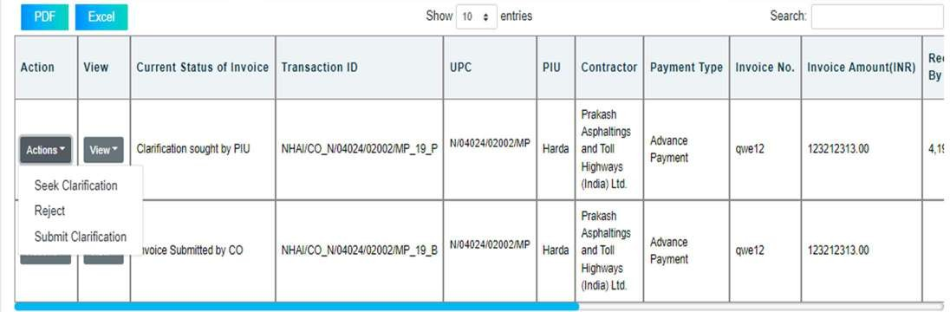

- On click “Submit Clarification” pop up will open, ADMIN can change his recommended amount if there is any change in calculation sheet.
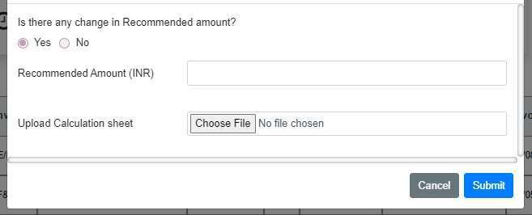

- On clicking “Submit Clarification” dairy function will open and ADMIN has to submit clarification by add note using digital signature and upload document(optional).
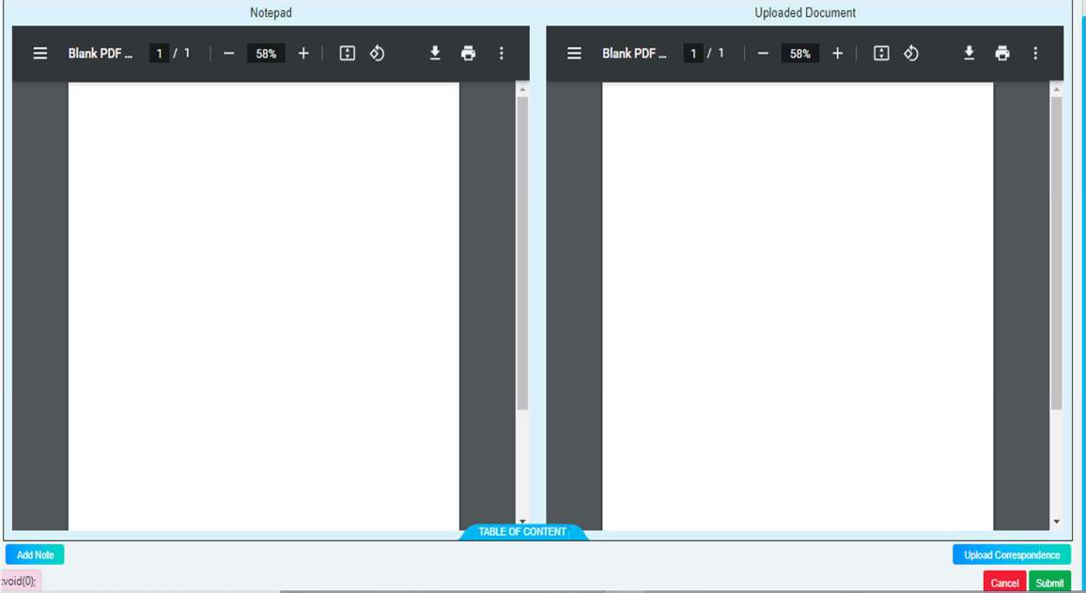

Rejection of contractor invoice.
      - ADMIN can reject Contractor invoice by clicking on “Reject” button.
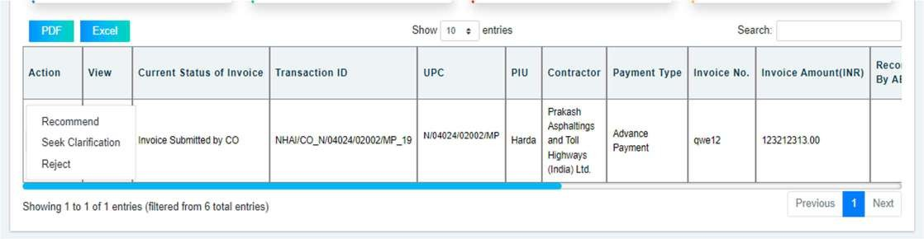

- On clicking “Reject” dairy function will open and ADMIN can reject by add note using digital signature and upload document(optional).
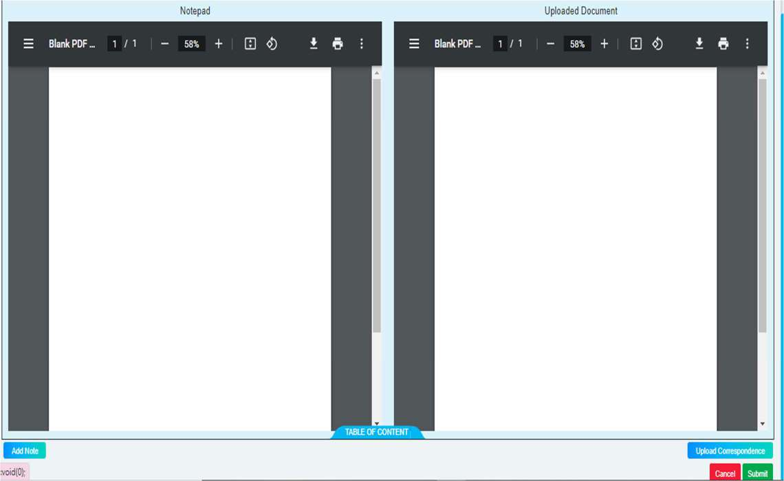

Submission of Out Standing payment invoice

Invoice Submission

- User to submit invoice by click on “Claim outstanding payment” from home screen.


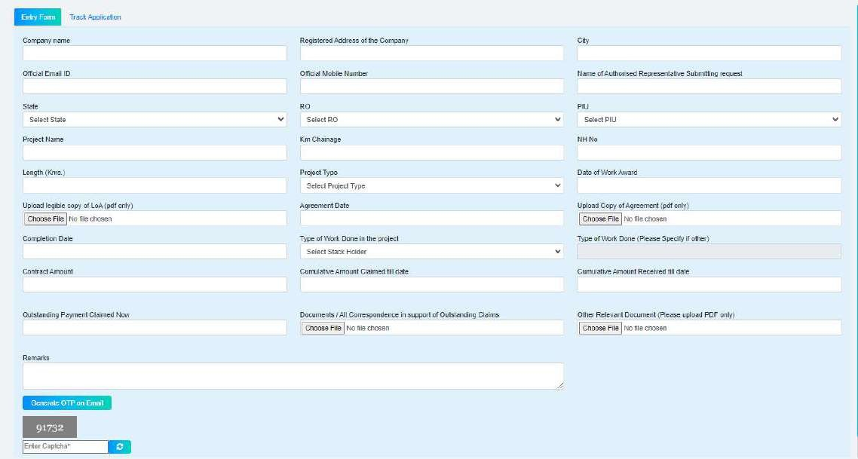
- User to fill form and submit details.

Activities to be performed by CLIENT/GOVERNMENT

Contractor invoice processing

View submitted invoice by Contractor
      - After recommendation of contractor invoice by ADMIN, details get displayed in CLIENT/GOVERNMENT grid and CLIENT/GOVERNMENT can view submission and activity log by clicking on “View” button.
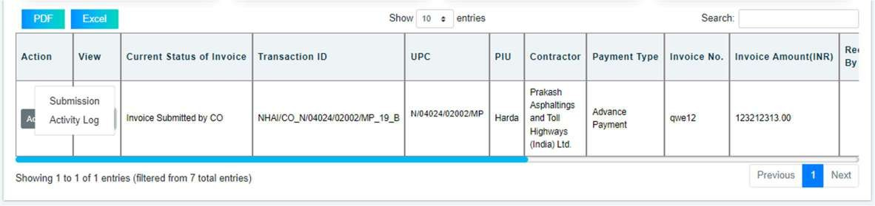

Rejection of Contractor invoice
      - CLIENT/GOVERNMENT can reject contractor invoice by clicking on “Reject”.
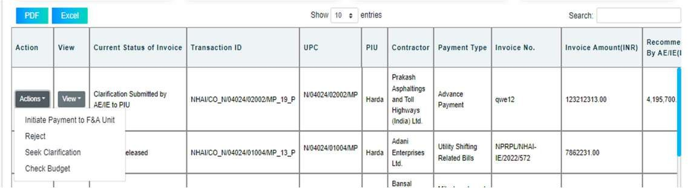

        - On clicking “Reject” dairy function will open and CLIENT/GOVERNMENT can reject by add note using digital signature and upload document(optional).
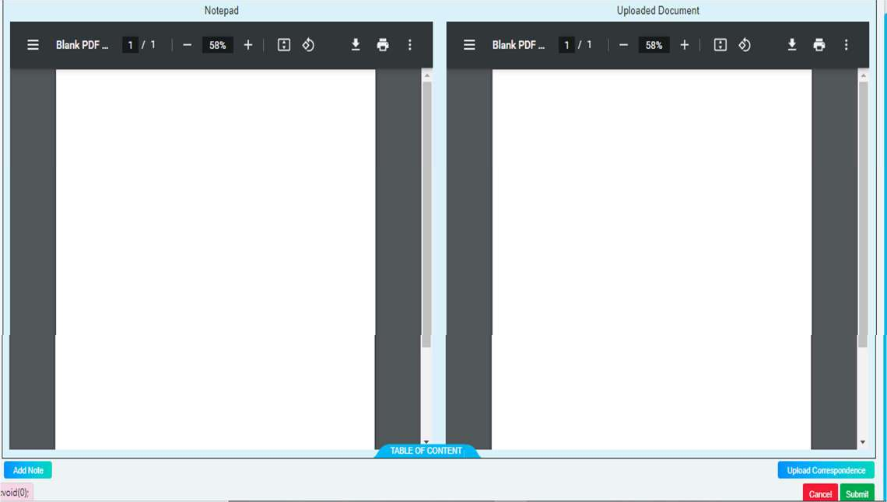

Seek clarification from ADMIN
      - CLIENT/GOVERNMENT can seek clarification from ADMIN by clicking on “Seek Clarification”.

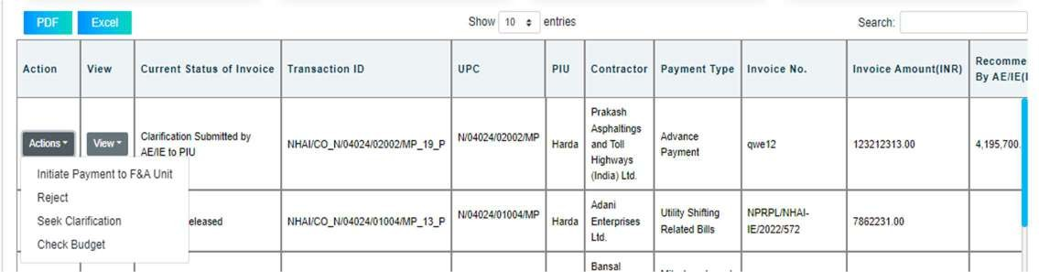

        - On clicking “Seek Clarification” dairy function will open and CLIENT/GOVERNMENT can seek clarification from ADMIN by add note using digital signature and upload document(optional).
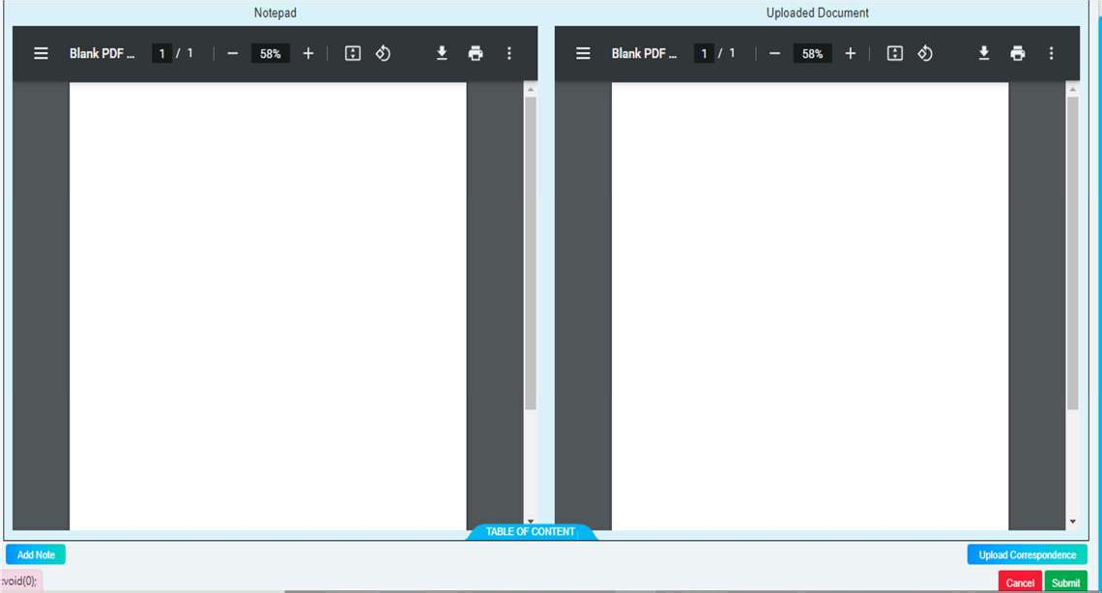

ADMIN invoice processing

View submitted invoice by ADMIN.
      - After submission of invoice by ADMIN, details get displayed in CLIENT/GOVERNMENT grid and CLIENT/GOVERNMENT can view submission & activity log clicking on “View” button.
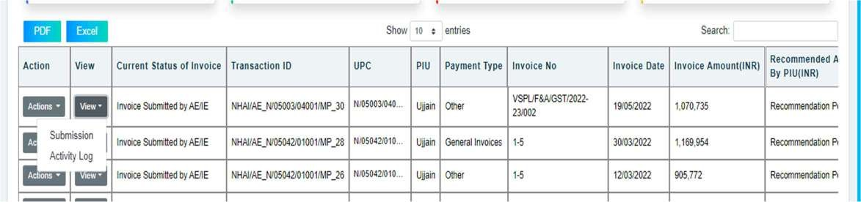

Rejection of ADMIN invoice
      - CLIENT/GOVERNMENT can reject ADMIN invoice by clicking on “Reject” option.
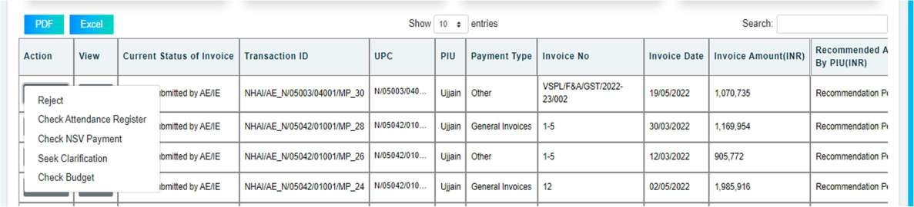

      - On clicking “Reject” option dairy function will open and CLIENT/GOVERNMENT can reject invoice by add note using digital signature and upload document(optional).
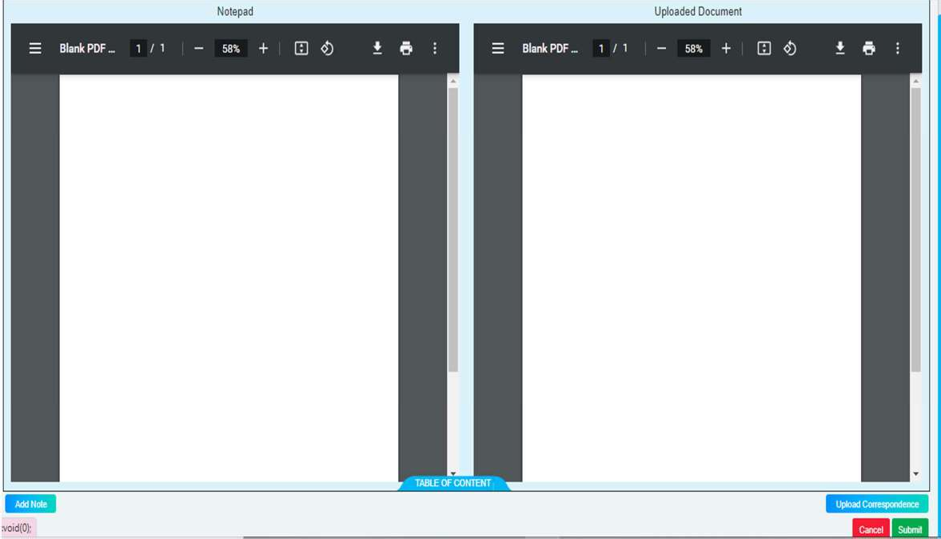

Check Attendance Register
      - CLIENT/GOVERNMENT has to check attendance of ADMIN personnel by clicking on “Check Attendance Register” option and fill required details.
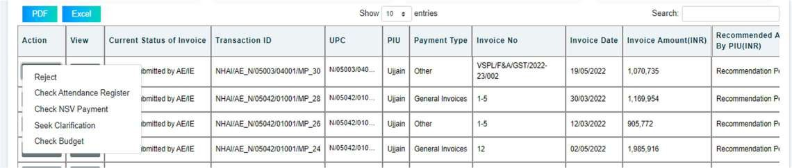
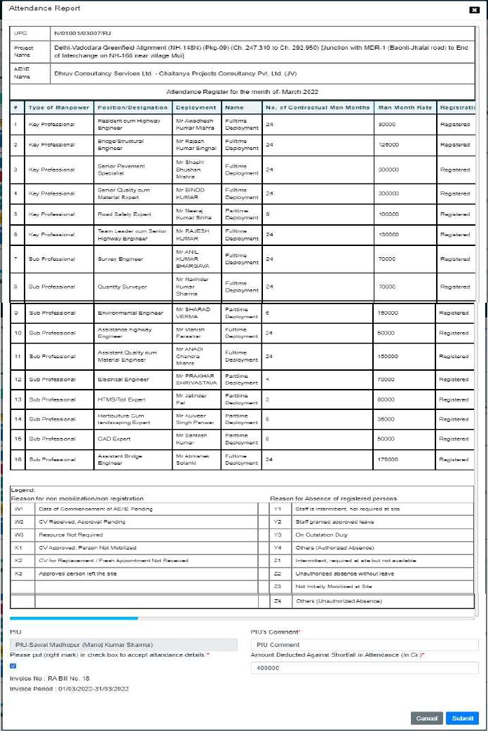

Seek clarification from ADMIN
      - CLIENT/GOVERNMENT can seek clarification from ADMIN by clicking on “Seek Clarification” option.
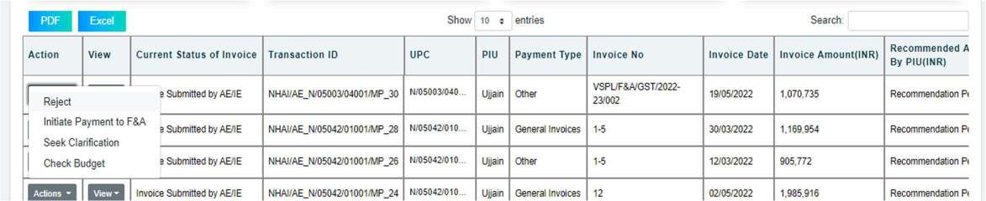

      - On clicking “Seek Clarification” option dairy function will open and CLIENT/GOVERNMENT can seek clarification by add note using digital signature and upload document(optional).
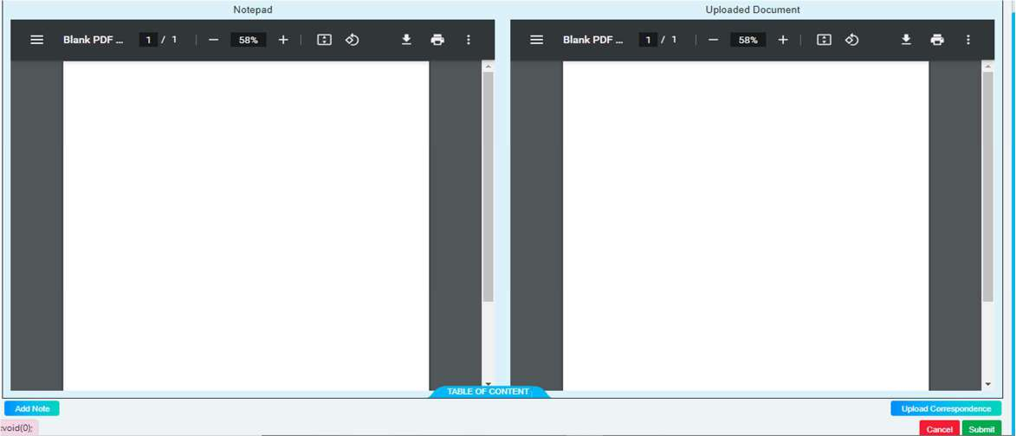

Outstanding payment invoice processing

View submitted invoice
      - After submission of invoice, details get displayed in CLIENT/GOVERNMENT grid and CLIENT/GOVERNMENT can view submission by clicking on “View” button.
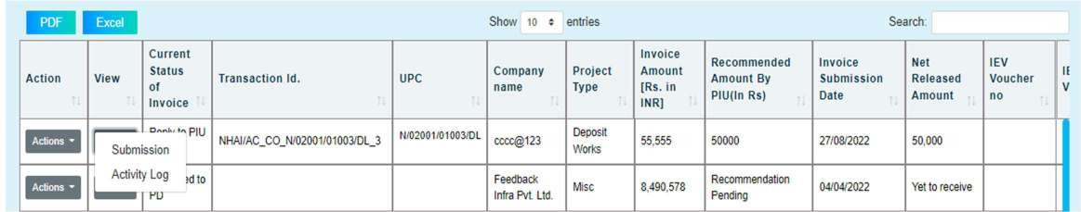

Assign UPC for processing
      - For processing the invoice CLIENT/GOVERNMENT has to add UPC by clicking on “Accept” option.
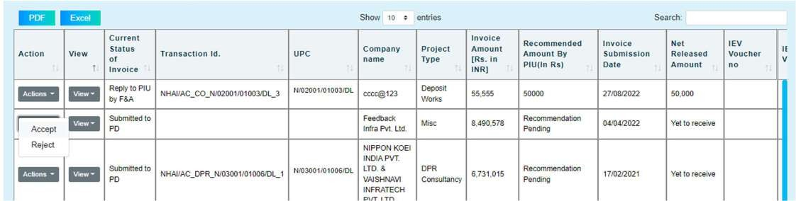

      - After clicking on “Accept” button CLIENT/GOVERNMENT has to select UPC from Dropdown in pop up window and submit.
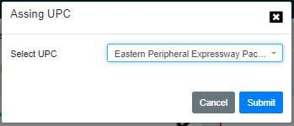

Rejection of submitted invoice
      - CLIENT/GOVERNMENT can reject invoice by clicking on “Reject” option.
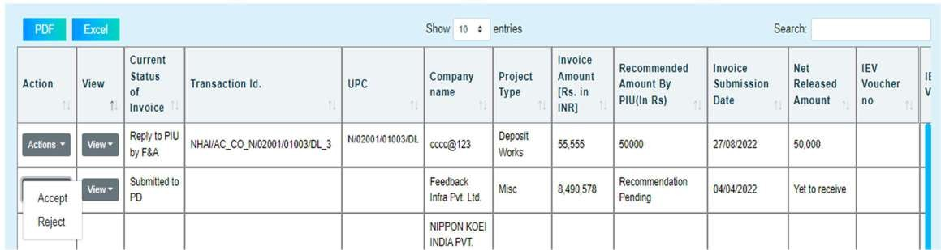

- On clicking “Reject” option dairy function will open and CLIENT/GOVERNMENT can reject invoice by add note using digital signature and upload document(optional).
